TITLE - TITRE
Presenting AUTHOR^{1,*}, Firstname NAME², Prénom NOM³
¹ Affiliation and address of presenting author / affiliation et adresse du premier auteur
² Second affiliation and address / Deuxième affiliation
³ Third Affiliation/ Troisième affiliation

Silicon carbide (SiC) is a promising wide band-gap semiconductor for high temperature, high power and high speed electronic devices. It has been also proposed for use in fusion reactor or nuclear waste technology. Therefore the behavior of SiC subjected to ion implantation is of prime importance.4H-SiC single crystal have been thus implanted at 1.6MeV using a van de Graff accelerator (CERI, Orléans) with a dose of 51016 He.cm-2. Samples have been mainly investigated using transmission electron microscopy (TEM). Conventional TEM has been performed with a JEOL-200CX microscope while a JEOL 3010 microscope has been used to achieve LACBED and CBIM experiments.
Cross-section TEM pictures (Fig. 1) evidence the presence of an amorphous layer (dark area in dark-field images) surrounded by two layers of defects (bright areas in dark-field images). The bottom layer of defects (far from the free surface of the sample) is about 50 nm thick with relatively sharp edges on both sides. On the contrary, the interface between the top layer of defect and the amorphous layer is rather diffuse. The interface between this second layer and the single-crystalline part of the sample located close to the free surface is the most diffuse: the defect density slowly decreases, leading to a thickness of about 150 nm. We have estimated the thickness of the amorphous layer to about 200 nm. These experimental values are in good agreement with simulated concentration profile of helium and defects (SRIM calculation). We do not observe any characteristic contrasts of helium bubbles or voids, as compared to sample implanted with higher dose (1017 He.cm-2)1.
The strains induced by the He implantation process have already been extensively studied by X-ray diffraction experiments. The most striking features of these studies are: first, the presence of two main diffraction peaks, one corresponding to the bulk parameter and the other to a strained lattice parameter; second, the presence of a large shoulder at low angles, near this second peak, that may be ascribed to a variation of the lattice parameter in the thickness of the sample.

Références/References :
[1] First Reference, Review, volume (year), p.1
[2] Arial 9, left-aligned, volume bolded (year), p.1

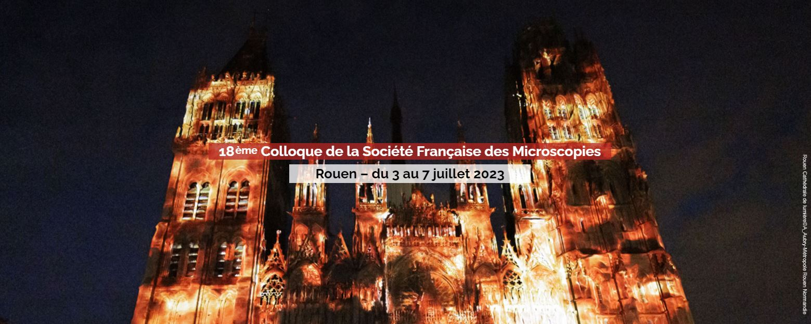

Figure 1: figures should be centered on the second page, caption written in Arial 10 Italic and centered.

Figure 2: Reims can easily be reached by train

*e-mail@corresponding-authors

